Georgios Papageorgiou

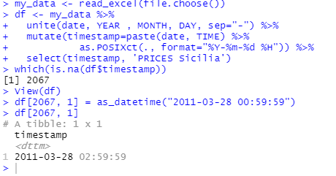

# produce the timeseries graph



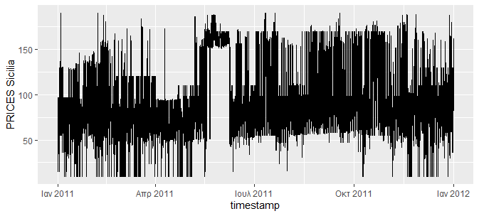

# calculate the proper time delay, we prefer ami beacuse usually is smaller



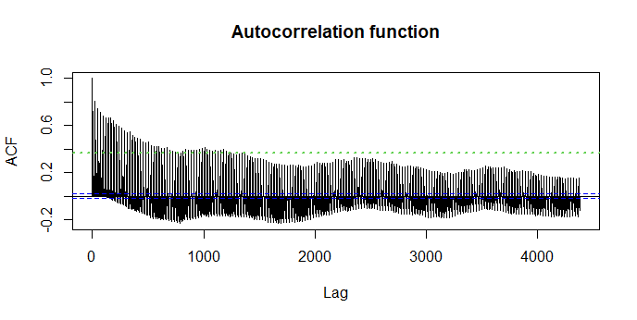



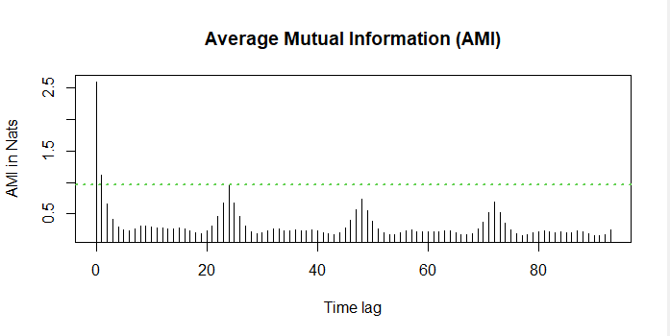

# produce the phase portrait graph



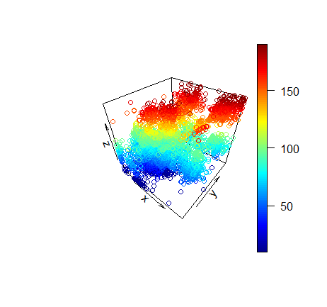

# calculate and produce the correlation integrals’ graph

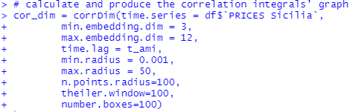

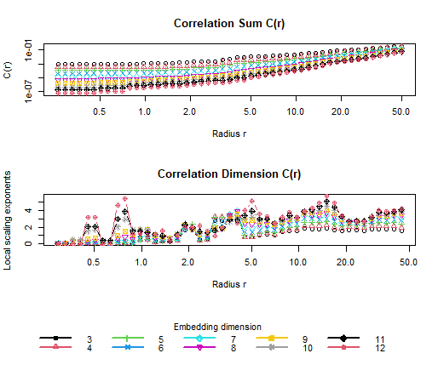

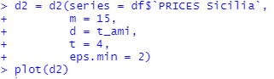

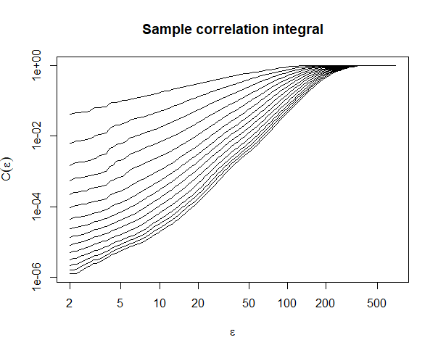

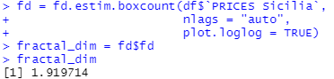

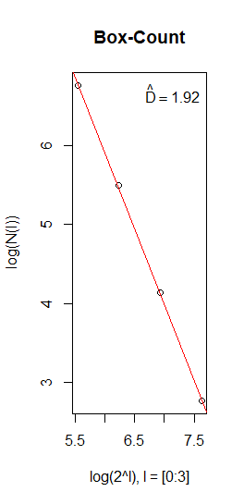

# produce the correlation dimension vs. embedding dimension graph and estimate the fractal dimension, the minimum embedding dimension and the essential embedding dimension

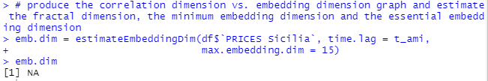

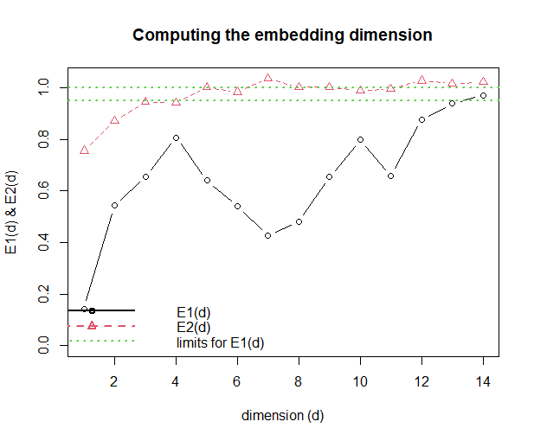

# calculate Kolmogorov entropy and (optional) produce the relevant graph

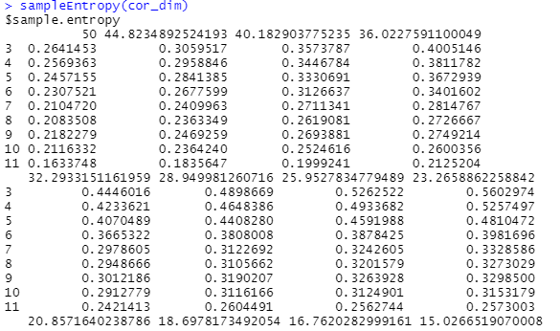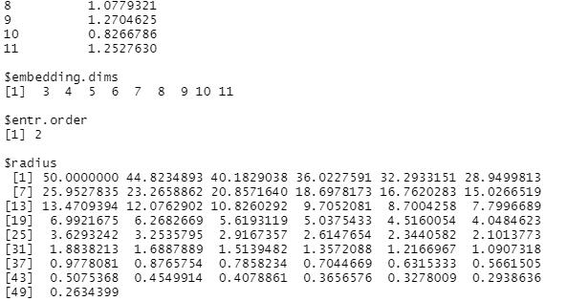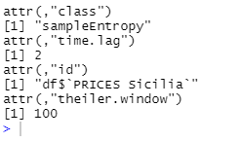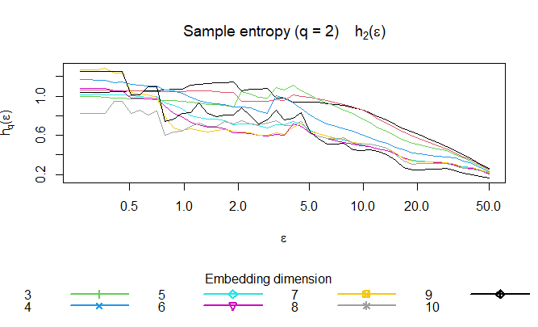

# Convert the power-price timeseries from hourly sampling (8160 points) to 4-hour sampling timeseries (2190 points), averaging the 4 points to be replaced for each new sample. Then follow the previous procedure.

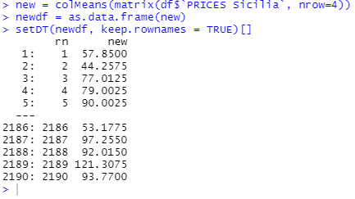

# calculate the proper time delay, we prefer ami beacuse usually is smaller



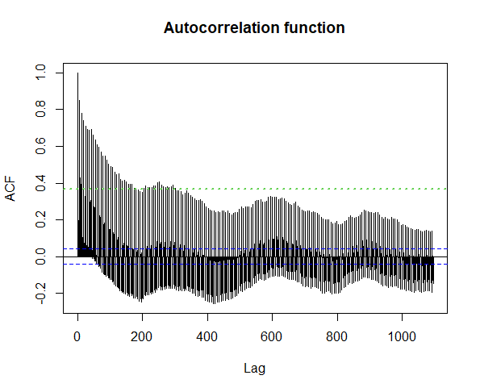



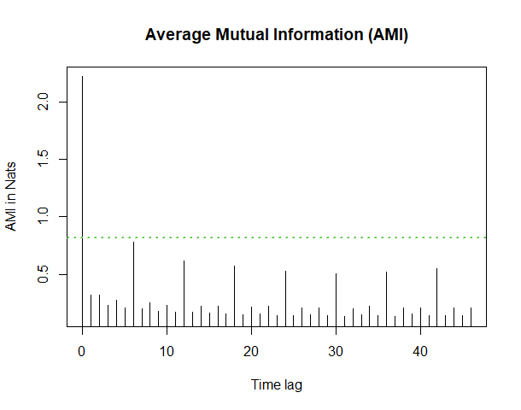

# produce the phase portrait graph



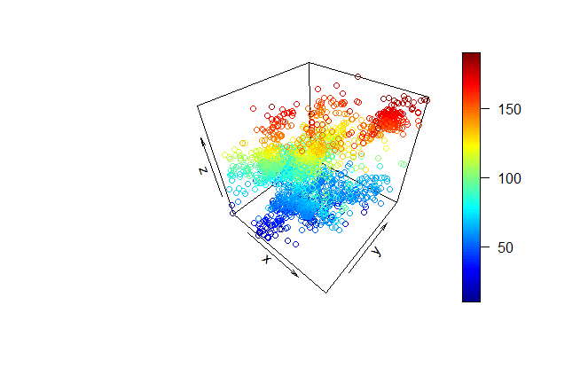

# produce the correlation dimension vs. embedding dimension graph and estimate the fractal dimension, the minimum embedding dimension and the essential embedding dimension

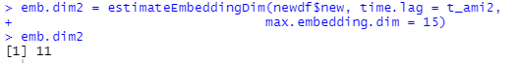

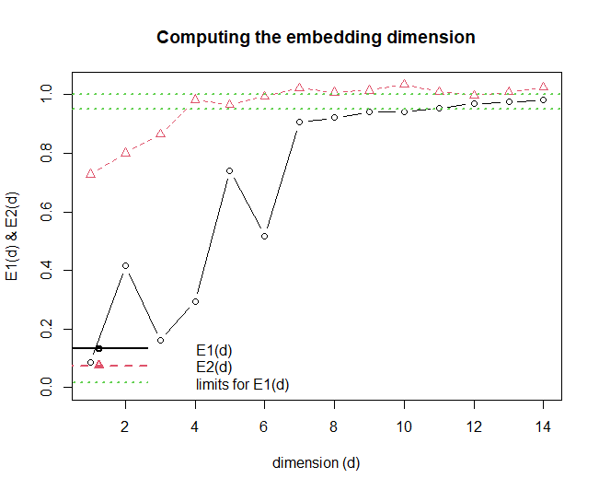

# calculate Kolmogorov entropy and (optional) produce the relevant graph

